# **Lesson Objectives**

1. Vertical and Horizontal Lines
2. Find equation of a line given its slope and a point (not *y*-intercept)
3. Find equation of a line given two points
4. Find equation of a line through a given point that is parallel or perpendicular to a given line

# Vertical and Horizontal Lines

## **Vertical** Lines

* Have **_______________________** slope
* Pass through the ***___*-AXIS**
* Are written in the form: ***_________________***, where *a* is some constant (number)
* *a* is the *x*-intercept, located at $(a, 0)$.
* **EXAMPLE:** Find the slope of the line in the figure. If the slope is undefined, so state. Then write an equation of the given line. [*Woodbury 3.3.37]

This is a VERTICAL line, so the slope of the line is **__________________**.

Since it passes through the ***x*-AXIS** at **– 7**, then the equation is ***_______***

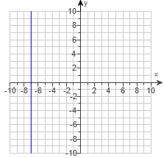

## **Horizontal** Lines

* Have **_____________** slope
* Pass through the ***_____*-AXIS**
* Are written in the form: ***________***, where *b* is some constant (number)
* *b* is the *y*-intercept, located at $(0, b)$
* **EXAMPLE:** Determine the equation of the given line, as well as the slope of the line. If the slope is undefined, state this. [*Woodbury 3.3.39]

This line passes through the ***y*-AXIS** at **– 6**, so the equation of the line is ***___________***.

Since this is a **HORIZONTAL** line,   
the slope is **___________**.

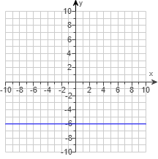

## Other examples with horizontal and vertical lines

* **EXAMPLE:** Write an equation for the line passing through the given pair of points.

$(–8,–3)$ and $(–8,–10).$ [2.1-14]

Always examine your given points before you do any math with them.

What do you notice? The ***___*-coordinates** are _____________________.

The equation of the line, therefore, is simply ***______________***.

Recommend you make a quick ___________ of this situation to help you understand it better.

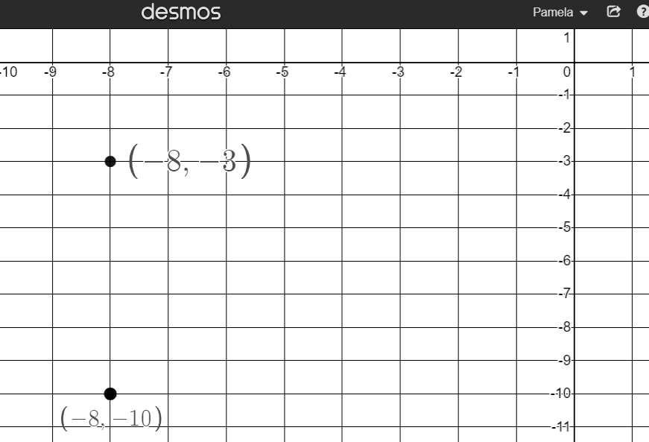

Notice that the **red** line through those points

passes through the *x*-axis at $x=-8$.

* **EXAMPLE:** Find the equation of the line satisfying the following conditions.  
  If possible, write the equation in slope-intercept form.

Vertical, passing through $(– 6.29,– 0.82)$ [2.1-24]

Vertical lines are of the form ***___________***

Simply use the *____*-coordinate of the through-point, so the equation is ***_________***.

Recommend you make a quick SKETCH of this situation to help you understand it better.

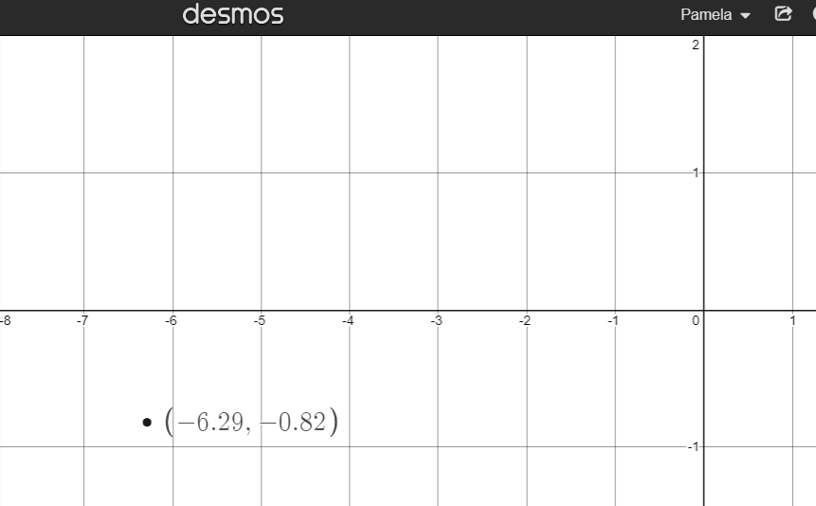

Notice that the **red** vertical line passes through

the *x*-axis at the SAME *x*-coordinate: $x=-6.29$.

* **EXAMPLE:** Determine the equation of the line described. Put the answer in slope-intercept form, if possible. Through $(– 9,– 7)$ perpendicular to $x = 2$. [2.1-35]

A line perpendicular to $x = a$ (vertical line) is a line of the form ***_______*** (horizontal line).

So, use the ***____*-coordinate** of the through-point. The equation is: ***____________*.**

Recommend you make a quick SKETCH of this situation to help you understand it better.

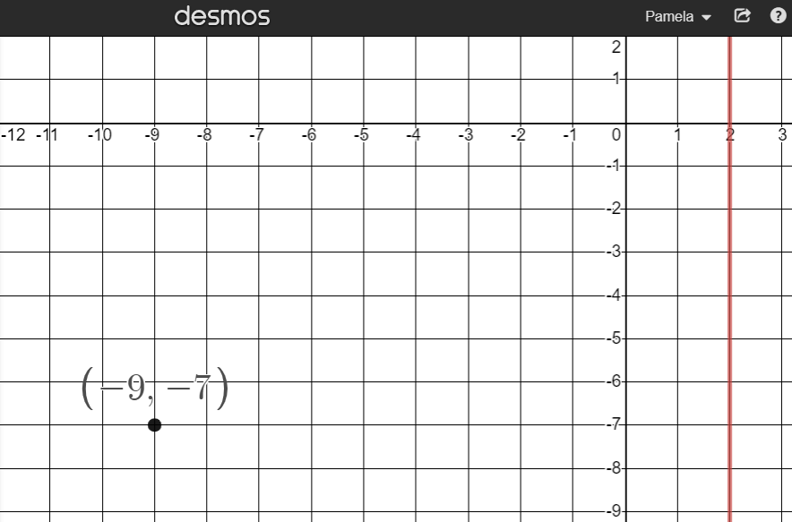

Notice that the line $x=2$ is shown in **red**.

The line perpendicular to it that passes through $(-9,-7)$

is the **purple** line passing through the *y*-axis at $y=-7$**.**

# Find equation of a line given its slope and a point (not y-intercept)

* **EXAMPLE:** Find an equation of the line that has the given slope and contains the given point. If​ possible, write the equation in​ slope-intercept form. Check that the ordered pair that represents the given point satisfies the equation. $m=\frac{7}{4}, (3,-4)$ [*Lehmann 5.4.7]

[SOLUTION] Use the **___________ ______________** formula: __________________

In words, this also means: ***y*-coordinate = slope (*x*-coordinate) + *y*-intercept**

Substitute all the given values: $y=mx+b$

Simplify:

Solve for *b*:

Update:

So, the equation is: $y=$

# Find Equation of Line Given Two Points

* **EXAMPLE:** Write an equation in slope-intercept form for the line described.

*x*-intercept $(– 4, 0)$, *y*-intercept $(0,5)$ [2.1.9]

First, you need the **_____________________**, so use the slope formula.

$$m=\frac{y_{2}-y_{1}}{x_{2}-x_{1}}=$$

Next, you need the ***____*-_________________**, which is given $(0,5)$, so ***_________***

So the equation of the line is: $y=____________________________$

* **EXAMPLE:** Find an equation of the line containing the given pair of points.

$(-1,-4)$ and $(-7,-8)$ [2.1.23]

First, you need the **_____________________**, so use the slope formula.

$m=\frac{y_{2}-y_{1}}{x_{2}-x_{1}}=\frac{ }{ }=\frac{ }{ }=\frac{ }{ }$ Equation so far: $y=$

Next, you need the ***___*-_______________**, which is _____ one of the two given points.

Use the **SLOPE-INTERCEPT** formula: $y=__________________$, and choose ___________ point.

|  |  |
| --- | --- |
| Either way works - you’ll get the same value for *b* choosing either point. | |
| **Using $(-1,-4)$ and $m=\frac{2}{3}$** | **Using $(-7,-8)$ and $m=\frac{2}{3}$** |
| $$y=mx+b$$ | $$y=mx+b$$ |
|  |  |
|  |  |
|  |  |
|  |  |

Finally, write your equation using your *m* and *b*: $y=$

# Parallel or Perpendicular Lines

## **Parallel** lines have **____________** slope (*m*), different *y*-intercept (*b*)

* **EXAMPLE:** Find the slope-intercept form of the line parallel to $-2x+3y=6$  
  and passing through the point $(-3,-4)$. [2.1.45]

Given line: $-2x+3y=6$. This is in **_________________** form: _____________________

We need it in **SLOPE-INTERCEPT** form: $y=mx+b$, so we can know its SLOPE (*m*).

We need to convert the given equation. This is a VERY important skill you need to know how to do – it will occur in later sections as well!

Given line: $-2x+3y=6$ The goal is to get *y* by itself: *y* = (all the other stuff)

Add 2*x*:

Simplify:

Divide by 3:

Simplified: This is *still* the *original* line – not the answer!

Slope of *GIVEN* line: $m=$

Need **__________________** (same slope), so slope of *NEW* line: $m=$

Equation so far: $y=$ We still need the *y*-intercept, *b*.

Use through-point $( , )$ with slope $m=____$ and plug into $y=mx+b$:

$y=mx+b$ $( x , y )$

Finally, write your equation using your *m* and *b*:

The equation of the new PARALLEL line is: $y=$

## **Perpendicular Lines** have **___________________ ______________________** slopes

**“switch” sign & “flip” fraction**

* **EXAMPLE:** Write the equation of the line containing the given point and perpendicular to the given line. Express your answer in the form $y=mx+b$. [2.1.43]

$(4, 6)$; $4x + y = 5$

Given line: $4x+y=5$ is in standard form.

Convert to slope-intercept form to know its slope.

Given line: $4x+y=5$ The goal is to get *y* by itself: *y* = (all the other stuff)

Subtract 4*x*:

Simplified: $y=$______________ This is *still* the *original* line – not the answer!

Slope of given line: $m=________$ Not done – don’t use this slope in the *NEW* equation!

Need: _____________________________ (OPPOSITE RECIPROCAL)

**____________** signand **________** fraction.

Convert given slope $=-4$:

Opposite (**Switch**): $m=______$ now do reciprocal (**Flip**): $m=\frac{ }{ }$

Slope of the **NEW** line is $m=$ Equation so far: $y=$

Use through-point $( , )$ with slope $m=____$ and plug into $y=mx+b$:

$y=mx+b$ $( x , y )$

Finally, write your equation using your *m* and *b*:

$________=b$ The equation of the PERPENDICULAR line is: $y=$

Sources used:

1. Desmos website: [www.desmos.com](http://www.desmos.com)
2. Pearson MyLab Math *College Algebra with Modeling and Visualization, 6th Edition*, Rockswold
3. Pearson MyLab Math *Elementary and Intermediate Algebra: Functions and Authentic Apps, 2nd Edition*, Lehmann
4. Pearson MyLab Math *Elementary and Intermediate Algebra, 3rd Edition*, Woodbury.
5. Wabbitemu calculator emulator version 1.9.5.21 by Revolution Software, BootFree ©2006-2014 Ben Moody, Rom8x ©2005-2014 Andree Chea. Website <https://archive.codeplex.com/?p=wabbit>